PART I (80 Marks)
2005

Mark your answers to Questions 1–40 on the SEPARATE MULTIPLE CHOICE ANSWER SHEET, using a 2B, B or HB pencil. If you make an error, follow the instructions given to you on the answer sheet.

SELECT THE SINGLE CORRECT ALTERNATIVE IN EACH OF THE FOLLOWING QUESTIONS

1. Urine is carried to the urinary bladder by

(a) blood vessels.
(b) lymphatics.
(c) the ureters.
(d) the urethra.

2. This question refers to the following list of characteristics:

(i) a domination by FSH from the anterior pituitary gland;
(ii) a domination by LH from the anterior pituitary gland;
(iii) oestrogens as the dominant ovarian hormone;
(iv) progesterone as the dominant ovarian hormone.

Of the above, which of the following pairings are characteristic of the preovulation phase of human reproduction?

(a) (i) and (iv)
(b) (ii) and (iv)
(c) (ii) and (iii)
(d) (i) and (iii)

3. A nervous impulse would travel fastest along

(a) a non-myelinated axon 30µm in diameter.
(b) a myelinated axon 25cm long and 15µm in diameter.
(c) a non-myelinated axon 15 cm long.
(d) a myelinated axon 15cm long and 20µm in diameter.

4. People affected with non-insulin dependent diabetes mellitus often have normal levels of insulin but the target cells of their body are not as sensitive to insulin as those of people who are unaffected. Using this information you could deduce that

(a) target cells do not have enough insulin receptors.
(b) target cells have too many insulin receptors.
(c) target cells already have enough glucose.
(d) glucagon is blocking receptor sites on target cells.

5. Which of the following statements about the thymus gland is NOT true.

(a) It activates B cells.
(b) It shrinks after puberty.
(c) It produces T cells.
(d) It lies approximately in the centre of the chest.

6. Inappropriate or excessive immune responses to one’s own cells are

(a) immunodeficiency diseases.
(b) autoimmune diseases.
(c) the result of allergies.
(d) the result of stress.

7. Which kind of synapse is most often found in the nervous system?

(a) electrical
(b) chemical
(c) mechanical
(d) saltatory

8. The ability to form concentrated urine depends on the functions of

(a) the proximal convoluted tubule.
(b) the distal convoluted tubule.
(c) the loop of Henle.
(d) Bowman’s capsule.

9. When the level of ADH increases,

(a) less urine is produced.
(b) less water is reabsorbed by the nephron and collecting duct.
(c) the concentration of the urine decreases.
(d) more salt is secreted by the nephron.

10. Most neurons do not have all the structures necessary for cell division. This could explain why neurons

(a) can communicate with one another.
(b) can transmit impulses.
(c) cannot regenerate after injury.
(d) have short dendrites.

11. Increased levels of carbon dioxide in the blood will result in which of the following?

(a) decreased cardiac output only;
(b) decreased blood flow to the lungs only;
(c) decreased parasympathetic stimulation of the heart only;
(d) a decrease in all of the above.

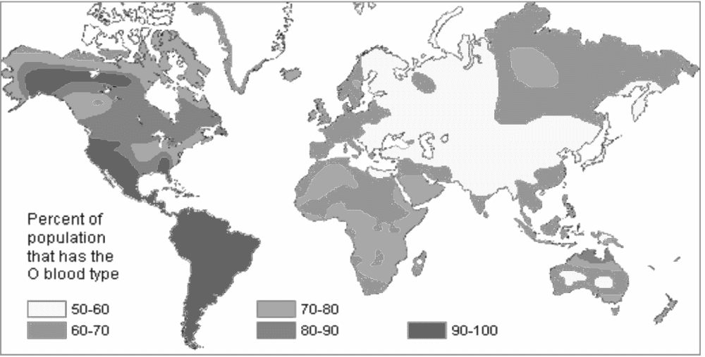
Percent of
population
that has the
O blood type
50-60
60-70
70-80
80-90
90-100

12. Given the percentages of O blood group illustrated above, the high proportion of O type blood in South America might best be explained by

(a) founder effect.
(b) genetic drift.
(c) selection.
(d) geographical isolation.

13. The human skin contains

(a) lysozyme, an enzyme which kills pathogenic bacteria.
(b) sebaceous glands that secrete cerumen, which kills pathogenic bacteria.
(c) sebaceous glands that secrete sebum, which has a protective function.
(d) hair and mucus which trap foreign particles and microorganisms.

14. A paleoanthropological research dig in South Africa finds a fire site with femur bones of antelopes, warthogs, and at least one hominid. All of the bones were burned at high temperatures and each has at least one cut mark on it. The site is dated at 1.3 million years ago. Which of the following is a reasonable interpretation?

(a) The hominid is an Australopithecine who hunted and cooked the other species.
(b) The hominid is an Australopithecine who may have been cooked by a Homo.
(c) The hominid is a Homo sapiens who died while cooking the other species.
(d) The hominid and other species were prey items of a non-hominid predator.

15. When humans began to cultivate plants, changes in lifestyle accompanied ecological changes. Which of the following changes is NOT likely to have occurred with this lifestyle change?

(a) Cultivators had a more diverse diet.
(b) Cultivators had more diseases with parasite vectors.
(c) Cultivators experienced more extreme population fluctuations in years of extreme climate.
(d) Cultivators had more specialisation of roles of production.

16. Which of the following is grouped with its appropriate characteristics?

(a) H habilis: Oldowan tools, controlled fire, carved figures, fully bipedal
(b) H. erectus: Acheulian tools, controlled fire, hunting spears, fully bipedal
(c) Australopithecus: Oldowan tools, hunting spears, carved beads, partially bipedal
(d) H. erectus: Ordovician tools, controlled fire, carved figures, fully bipedal

17. Pongids and hominids share which of the following sets of traits?

(a) dorsally rotated scapula; reduced canines; short broad pelvis
(b) reduced canines; same number of molar teeth; short broad pelvis
(c) dorsally rotated scapula; forelimbs longer than hindlimbs; nails instead of claws
(d) dorsally rotated scapula; same number of molar teeth; nails instead of claws

18. This question refers to the following list of environmental changes.

(i) increasing CO₂;
(ii) increasing soil erosion;
(iii) decreasing biodiversity;
(iv) decreasing greenhouse gases;
(v) increasing ozone layer.

Which combination of these changes are direct ecological effects of the clearing of rainforests?

(a) (i), (ii) and (iii)
(b) (ii), (iii) and (iv)
(c) (iii), (iv) and (v)
(d) (i), (iii) and (v)

19. The population pyramid of an aging population will show

(a) a narrower base and a wider middle than top.
(b) a narrower base and a wider top than middle.
(c) a wide base, narrower middle and a wide top.
(d) a top that is wider than the bottom or middle.

20. Which ONE of the following statements best illustrates artificial active immunity?

(a) Antibodies in breast milk enter the baby’s bloodstream.
(b) Antigens are made when a person suffers an attack of a disease.
(c) Antibodies are injected into the bloodstream.
(d) Antigens are injected into the bloodstream.

Amylase is an enzyme that hydrolyses starch into sugars in humans. An experiment was performed to determine the effect of temperature on amylase activity. The data collected are given in the following table.

Refer to this table for questions 21 and 22.

Temperature (ºC) | Rate of production of sugar (g/min)
0 | 0.0
10 | 0.4
20 | 0.6
30 | 0.8
40 | 1.0
50 | 0.4
60 | 0.2
70 | 0.0

21. The independent variable in this experiment is

(a) the rate of hydrolysis of starch into sugars.
(b) the rate of amylase activity.
(c) the incubation temperature.
(d) the concentration of amylase.

22. What factors need to be controlled in this experiment?

(a) amylase activity and incubation temperature
(b) concentration of amylase and amount of starch
(c) concentration of amylase and amount of sugar
(d) amylase activity and amount of starch

Refer to the following information for questions 23 and 24.

Both parents of a child have blood group B. They have a son who has blood group O.

23. The respective genotypes of the mother and father are

(a) I^{B} I^{B} and I^{B} I .
(b) i i and I^{B} I^{B} .
(c) I^{B} i and I^{B} i .
(d) i i and i i .

24. What is the probability of their next child having blood group O?

(a) 0.25
(b) 0
(c) 0.5
(d) 1.0
25. An obstruction in the glomerulus would block the flow of blood into the

(a) renal artery.
(b) efferent arteriole.
(c) afferent arteriole.
(d) interlobular arteriole.

26. For natural selection to occur,

(a) interbreeding between populations must take place.
(b) mutations must be frequent.
(c) populations must be completely isolated from other species.
(d) there must be variation within a species.

27. Evolution is a result of

(a) mutations only.
(b) mutations and natural selection only.
(c) mutations and natural selection or genetic drift.
(d) natural selection only.

28. Thermoreceptors are located in the

(a) skin only.
(b) skin and hypothalamus.
(c) skin and lungs.
(d) hypothalamus only.

29. One effect of endurance training in athletes (e.g. marathon runners) can be a lowering of the heart rate. This

(a) is a result of enlargement of the cardiac muscle.
(b) is a sign of over-exertion.
(c) will result in a decreased cardiac output.
(d) will result in a decreased O₂ carrying capacity of the blood.

30. Of the following statements, which is true concerning feedback mechanisms?

(a) A positive feedback mechanism will operate to maintain homeostasis.
(b) A negative feedback mechanism will tend to increase the original stimulus.
(c) A negative feedback mechanism will work to prevent sudden, severe and sustained changes within the body.
(d) A positive feedback mechanism controls body temperature and blood glucose levels.
31. Which of the following demographic measures provides an indication of the potential for genetic drift?

(a) migration rates
(b) birth rates
(c) death rates
(d) population size

32. Which of the following is true of the Greenhouse Effect?

(a) Increased concentrations of greenhouse gases over developed countries have resulted in a depleted ozone layer at the poles.
(b) Increased greenhouse gases reduce the amount of heat radiated by the earth into space.
(c) The greenhouse effect causes ocean levels to fall due to increased evaporation.
(d) Deforestation of tropical forests is the primary contributor to increased greenhouse gases.

33. Which of the following is a true statement regarding pollution?

(a) Organic materials that run off into waterways react with oxygen and result in fish die-offs.
(b) Acid rain results in an excess of O₂ levels in waterways.
(c) Methane and heavy metals are responsible for ozone depletion.
(d) Heavy metals accumulate in the food chain and may cause deformities in humans.

34. When sound waves enter the ear they are converted into mechanical movements by the

(a) tympanic membrane.
(b) oval window.
(c) round window.
(d) cochlea.

Questions 35 and 36 refer to this diagram of a skull.

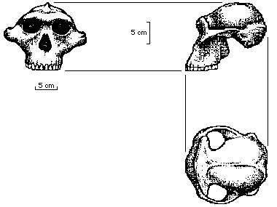

35. Identify the correct group and characteristic features of the specimen in the diagram above.

(a) Pongidae: prognathic, sagittal crest, robust mandible
(b) Australopithecines: prognathic, reduced incisors, robust cranium
(c) Neanderthals: elongate cranium, occipital bun, eyebrow ridges
(d) Homo sapiens; elevated vault of the skull, eyebrow ridges, reduced incisors

36. This specimen was most likely found in

(a) Indonesia.
(b) China.
(c) Africa.
(d) North America.
Questions 37 and 38 refer to the information and table below.
Four disinfectants were diluted and tested on cultures of a micro-organism (at standard temperature and pressure). The results are shown in the table below where:
+ indicates that bacteria grew, and
- indicates no growth.

Disinfectant
Dilution | A | B | C | D
1:2 | + | - | - | -
1:4 | + | - | + | -
1:8 | + | + | + | -
1:16 | + | + | + | +

37. Of the four disinfectants tested, which was most effective?

(a) disinfectant A
(b) disinfectant B
(c) disinfectant C
(d) disinfectant D

38. Why are you led to this conclusion?

(a) Bacteria showed growth at all dilutions.
(b) Bacteria showed growth only in the most dilute solution.
(c) Bacteria showed growth in the less dilute solutions.
(d) Bacteria showed no growth in the less dilute solutions.

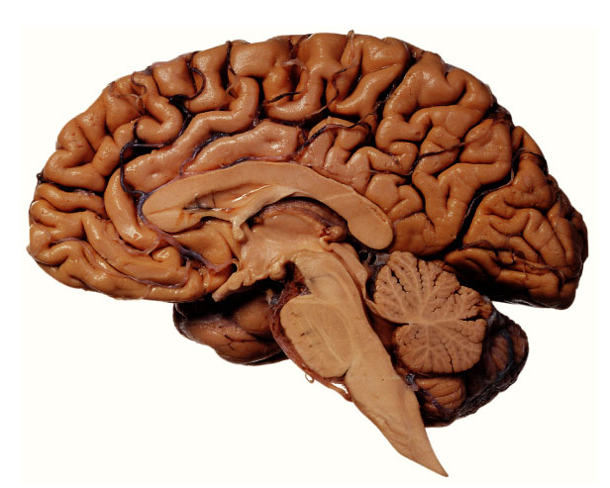
A

39. The structure labelled A in the picture above is the

(a) cerebrum.
(b) hypothalamus.
(c) thalamus.
(d) medulla.

40. The white matter of the medulla

(a) communicates between the cerebrum and spinal cord.
(b) relays sensory and motor information to the cerebellum.
(c) regulates rate and force of contraction of the heart.
(d) controls respiratory movements.

PART II (80 Marks)

Write answers to ALL questions on the ruled lines after each question or in the spaces provided within each table. Write your answers in blue or black ballpoint or ink pen.

Question 41 (Total 12 marks)

Refer to the following pedigree. In each generation (I, II, III, etc.) individuals are identified by numbering from the left to the right across the pedigree (I.1, I.2, III.3, etc).

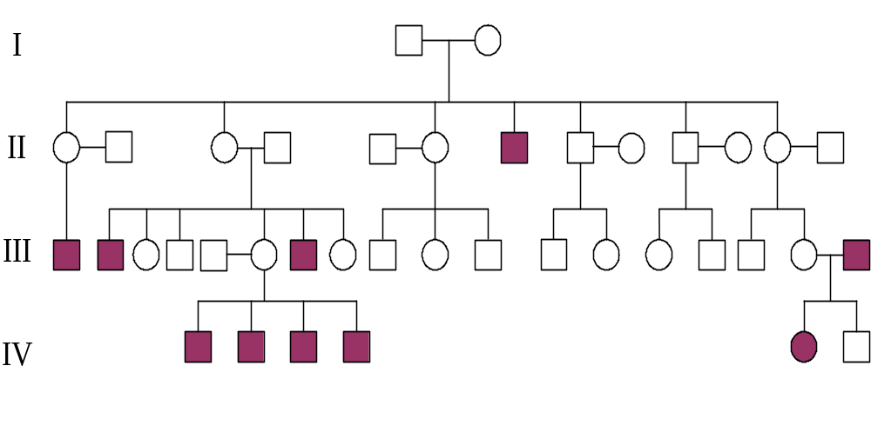
(a) From the evidence in the pedigree, state whether this condition is most likely to be transmitted on an autosomal chromosome or a sex chromosome.

(1 mark)

(b) Explain how you arrived at your answer to (a).

(2 marks)

(c) Indicate whether this is a dominant or a recessive allele. (1 mark)

(d) Using R to indicate dominant, and r to denote recessive alleles, the genotype of individual III.6 is
(2 marks)
(e) If III.9 and III.17 were to marry, what is the probability that a child born to them will have the affected phenotype?

(2 marks)

(f) Given the genotype of III.6, what was the probability that she would have the children that she did? Show your work.

(4 marks)

Question 42 (Total 8 marks)

The evolutionary record indicates that humans have developed different ways of using their environments over time – these are sometimes termed ‘lifestyles’.

(a) What is the oldest lifestyle documented for Homo sapiens?

(1 mark)

(b) Describe the relative population size and density of humans living this lifestyle.

(2 marks)

(c) What are two lifestyles that emerged from the oldest human lifestyle?

(2 marks)

(d) What are three disadvantages (decreased quality of life) associated with these two lifestyles?

(3 marks)

THIS PAGE HAS BEEN LEFT BLANK INTENTIONALLY

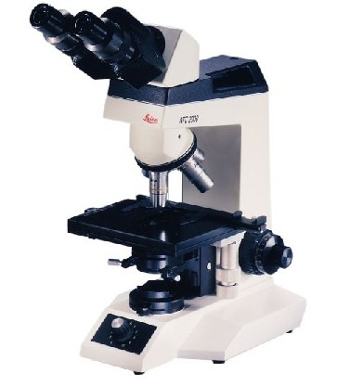
A
B
Question 43 (Total 7 marks)

Refer to the microscope pictured on the opposite page.

(a) On the diagram of a microscope, what is the part of the microscope labelled A called?

(1 mark)

(b) What is the function of the part of the microscope labelled B?

(1 mark)

(c) You are given a slide and told that it contains bacteria and viruses which are to be observed under a light microscope. Indicate what you will see through this microscope, and explain why.

(2 marks)

(d) You have focused on some cells on a slide and are given the following information:

Magnification on microscope: 1000X
Field of view at this magnification: 100μm
Length of cell in your drawing: 2cm
Estimate of length of cell in microscope: 10μm

Use this information to answer the following questions. Show all working.

(i) How many cells would fit across the field of vision of this microscope?

(1 mark)

(ii) What is the magnification of the drawing compared to the cells on the slide?

(2 marks)

Question 44 (Total 14 marks)

(a) What is the difference between active immunity and passive immunity?

(4 marks)

(b) Which is more effective in producing long term immunity, active or passive immunity?
Explain why?

(4 marks)

(c) Susan’s right index finger is red, swollen and painful. After a few days, the redness and swelling seem to have spread along her finger. She visits her local doctor and is told that it is likely to be a bacterial infection. Her doctor prescribes an antibiotic.

(i) What is required for an antibiotic to be effective?

(2 marks)

(ii) Provide a specific example of an antibiotic and its mechanism of action.

(2 marks)

(iii) Explain two major problems associated with the use of antibiotics.

(2 marks)

Question 45 (Total 12 marks)

(a) The following are descriptions or functions of structures found in the eye.
(5 marks)

A. stimulated by bright light and responsible for colour vision;
B. covers the external surface of the cornea and lines the inside of the eyelids;
C. round black hole through which light reaches the inside of the eye;
D. stimulated by dim light;
E. the white part of the eye;
F. produces the sharpest vision.

For each structure listed below, write the one letter best associated with the appropriate description or function.

(i) Sclera

(ii) Rods

(iii) Fovea

(iv) Cones

(v) Conjunctiva

(b) Using arrows and labels, clearly identify the blind spot, sclera and iris in the diagram of the eye below.
(3 marks)
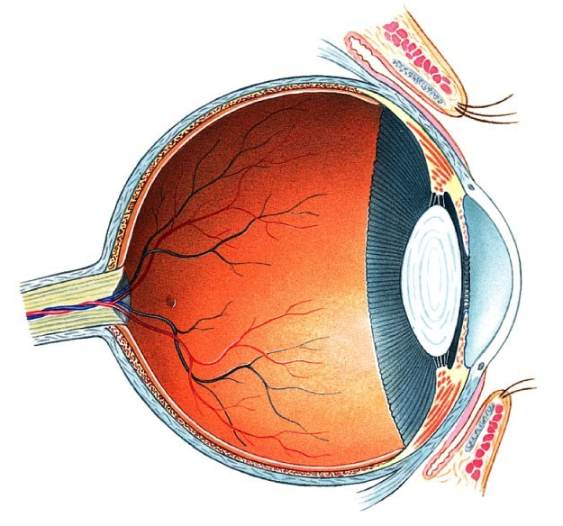

(c) A person can see distant objects clearly but not close objects. This is called ‘hypermetropia’. A convex lens will correct this defect. Explain how this lens corrects the person’s vision. You may use diagrams to clarify your explanation.

(4 marks)

Question 46 (Total 11 marks)

(a) The main hormone released from the thyroid gland is

(1 mark)

(b) A person is suffering from hyperthyroidism, where too much thyroid hormone is secreted. One of the symptoms suffered is excessive heat production. What is the term that describes the transfer of this excess heat energy to the air?

(1 mark)

(c) Thyroid hormones and TSH levels were measured in a person suffering from hypothyroidism (thyroid gland does not produce sufficient thyroid hormone). If the problem was with the thyroid gland itself, would you expect to see elevated or decreased levels of TSH? Why? (Include all relevant structures in your answer.)

(4 marks)

(d) A person’s blood pressure is rather high and needs to be lowered. The anatomical structures responsible for detecting this high blood pressure are called

(1 mark)

(e) Assuming that the blood pressure has been lowered, what effect will this have on the volume of lymphatic fluid produced?

(1 mark)

(f) Explain why you arrived at your answer to part (e).

(2 marks)

(g) Name one component of body fluids that must be kept constant.

(1 mark)

Question 47 (Total 7 marks)

The graph below indicates population processes for a single population over a period of 275 years. Refer to the graph below to answer the following questions.

Birth and Death Rates by Year
0
10
20
30
40
0
25
50
75
100
125
150
175
200
225
250
275
Years
Crude Rates
death
birth
Stage A
Stage B
Stage C
Stage D

(a) What is the name given to the suite of changes graphed above?

(1 mark)

(b) What is the first alteration in population processes that begins this suite of changes?

(1 mark)

(c) To the nearest labelled year, in what year did the suite of changes begin?

(1 mark)

(d) During what stage was the population increasing most rapidly?

(1 mark)

(e) Explain why you arrived at your answer to part (d).

(2 marks)

(f) Australia is currently in which stage of this suite of changes?

(1 mark)

Question 48 (Total 9 marks)

The rows of diagrams below show the appearance of a number of vertebrate embryos and the adult form. Use this information to provide detailed answers to the following questions.
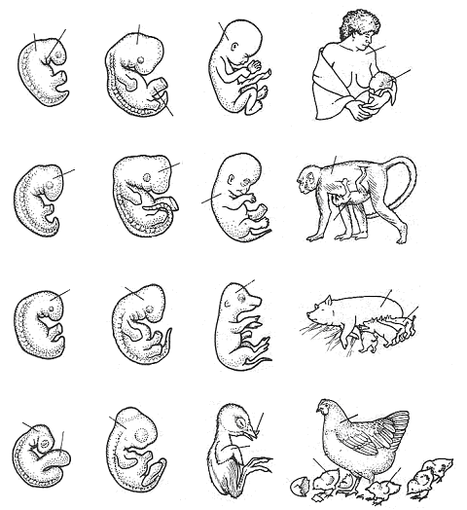
D
D
D
D
Gill Slit
E
Umbilicus
F
G²
G¹
E
E
Yolk
Sac
E
Shell
Breaker
F
G
G
G²
G²
G¹
G²
G¹
F
F
species 1
species 2
species 3
species 4

(a) What process is illustrated in each row of diagrams?

(1 mark)

(b) When comparing this process among the four species above, what two generalisations are clear?

(2 marks)

(c) Explain how these generalisations may be used to support the theory of evolution.

(2 marks)

(d) What are two other lines of evidence that support the theory of evolution?

(2 marks)

(e) Why might comparative biochemical studies (DNA or proteins) of species be more precise in demonstrating genetic relationships than are comparative studies of morphology (structures)? Give an example to demonstrate your answer.

(2 marks)

PART III (40 MARKS)

Answer ONE question from SECTION A and ONE question from SECTION B. Illustrate your answers with diagrams where appropriate. Up to TWO MARKS may be deducted for poorly structured answers: that is, answers in point form or diagrams not explained in the text of your answers. DO NOT WRITE ANSWERS IN PENCIL. Write your answers on the lined pages in your Question/Answer Booklet following the end of the questions.

SECTION A

ANSWER EITHER QUESTION 49 OR QUESTION 50 – NOT BOTH

QUESTION 49 (Total 20 marks)

A human female is born with approximately 2 million immature follicles in her two ovaries. Following puberty, a few of these immature follicles mature and release an ovum, on average, every 28 days.

(a) Discuss the roles of hormones in producing changes to the ovary and the lining of the uterus in one menstrual cycle. You may use diagrams to illustrate and clarify your discussion.
(14 marks)

(b) The contraceptive pill contains oestrogen alone or a combination of oestrogen and progesterone. Set dosages are taken throughout the ovarian cycle to stop both follicle maturation and ovulation. Explain why this occurs by referring to your answer to
part (a).
(6 marks)

OR

QUESTION 50 (Total 20 marks)

(a) Students under exam stress often relax in a hot bath. One such student raises the water temperature as high as he can and then gets in. After a few minutes he feels faint and loses consciousness. His parents notice this and pull him from the bath. Since this is a vascular problem, explain why he lost consciousness.
(6 marks)

(b) In congestive heart failure the heart does not pump with enough force. A symptom of congestive heart failure is swollen ankles and feet. Explain the process that causes this swelling with reference to pressure and concentration gradients.
(7 marks)

(c) Shock is a potentially life-threatening condition that may result from a serious illness or injury. When someone suffers from shock a number of symptoms occur, including the skin becoming cold and clammy, a weak and rapid pulse, rapid breathing and a decreased venous return to the heart. When people receive bad news or witness an upsetting incident, this can produce shock. How does shock of this type produce a decreased venous return? (Hint: the central nervous system is involved in this case.)
(7 marks)
SECTION B

ANSWER EITHER QUESTION 51 OR QUESTION 52 – NOT BOTH

QUESTION 51 (Total 20 marks)

Humans (Homo sapiens) migrated out of Africa during the last 150,000 years. Migrants encountered, and adapted to, a wide variety of environments. Humans colonised Australia between 50 and 70 thousand years ago.

(a) Discuss two major characteristics of land masses that influenced the pathways that humans used to spread into new areas – you may use the spread of Homo sapiens into Australia to illustrate your answer.
(4 marks)

(b) Describe the lifestyles of Homo sapiens prior to 20,000 years ago.
(4 marks)

(c) Discuss two behavioural and four physiological or structural adaptations of
Homo sapiens to arid (hot and dry) environments.
(12 marks)

OR

QUESTION 52 (Total 20 marks)

A trekker walking in the hills of Indonesia found a fossil skull and brought it to a human biologist working in a forensics laboratory.

(a) Discuss five characteristics that the human biologist would look for to indicate that the skull belonged to a hominid.
(5 marks)

(b) Describe four techniques that can be used to assign a date to fossil materials. Also, distinguish which of these techniques might be used by the human biologist to date the skull. Explain your answer.
(10 marks)

The picture below resembles the skull that was delivered to the human biologist. The skull was dated to approximately 500,000 years ago.

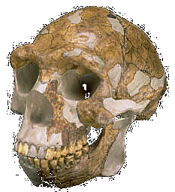

(c) To what species does this skull MOST LIKELY belong? Explain the reasons (evidence) for your identification.
(5 marks)

END OF PAPER

ACKNOWLEDGEMENTS

Question 39 & 45: Martini, F.M (2004). Fundamentals of anatomy and physiology (6th ed.). San Francisco: Benjamin Cummings.

Question 43: Tortora, G.J., Funke, B.R., & Case, C.L. (2004). Microbiology: An introduction (8th ed.). San Francisco: Benjamin Cummings.

Question 12: Freeman, S., & Herron, J.C. (2004). Evolutionary analysis (3rd ed.). Upper Saddle River, NJ: Pearson Prentice Hall.

Question 48: Zihlman, A.L. (1982). The human evolution coloring book. New York Barnes and Noble.

Question 35 & 36: Diagram from: Skeletons in your closet 8—Australopithecus robustus. (n.d.). Retrieved June, 2005, from University of California, Santa Barbara, Department of Anthropology website: http://www.anth.ucsb.edu/faculty/stsmith/classes/anth3/courseware/Hominids/08_A_robustus.html

Question 52: Photograph from: Fossil hominids: Homo erectus skull Peking Man BH-005. (2004). Retrieved June, 2005, from Bone Clones website: http://www.boneclones.com/BH-005.htm

Published by the Curriculum Council of Western Australia
27 Walters Drive
OSBORNE PARK WA 6017

